ROW Build Guide
Sep 29, 2026 · @Pranav

What we are building
Roster On Wheels (ROW) is the international edition of RIZones45678. It is not a new product and not a fork. It is the same codebase deployed a second time, with its own brand, database, domains, providers and settings. Everything RIZones does today must keep working exactly as it does now.
ROW is complete and live on Sunday 15 November 2026. Code freezes on Wednesday 28 October 2026.
For where India-specific logic sits in the code today, use Appendix A of ROW Platform Strategy and Architecture v1.0. Where that document and this guide differ, follow this guide.

Team and ownership
Engineer | Focus | Owns
BW1 | Backend and web | Secrets, server setup, brand configuration, master data, privacy
BW2 | Backend and web | Payments, messaging, club subdomains
F1 | Flutter apps and backend | Locale and time zones, phone and OTP, Rotary.org sync, and the app screens for each
F2 | Flutter apps and backend | Translation across web and app, ROW app build, store listings
Owners write the code for their packages and are first reviewer on any change that touches them. All four take part in regression and the pilot.

Architecture at a glance
The same code produces both columns. The difference comes only from each instance's configuration.
Layer | RIZones45678 | ROW
Code | One repository, one release | Same repository, same release
Server | Existing Windows/IIS server in India | Same server, isolated as described in Server setup
Database | Existing MySQL instance | Own MySQL instance on its own port
Domain | rizones45678.org | ROW domain, read from brand configuration
Edge | Unchanged | Cloudflare Pro in front of every ROW hostname
Payments | Cashfree and Razorpay, 18% GST | Stripe Checkout or PayPal on each district's own account; tax by country
WhatsApp | Interakt | WhatsApp Cloud API directly from Meta
OTP | Unchanged | Email and WhatsApp; Twilio SMS as fallback
Email | Brevo, RIZones sender | Brevo, ROW sender domain
Time | IST | Each district's own time zone; UTC in the database
Phone numbers | +91 | E.164, any country
Languages | Unchanged | English, French, German, Italian, Japanese, Korean, Portuguese, Spanish
Club websites | Existing domains through Plesk | Subdomains of the ROW domain through Plesk
Master data | Source of truth, committed as seed files | Loaded from the same seed files, read only
Users and login | Own user store and JWT key | Own user store and JWT key
Rotary.org sync | India, Sri Lanka, Nepal | Zones and countries from configuration
Mobile app | RIZones app | ROW flavour of the same Flutter code

Ground rules for every change
These apply to every commit from today, whoever or whatever writes the code.
- No brand checks in code. Never write a condition on the brand name. Every difference between RIZones and ROW is a configuration value, an injected provider or a feature flag.
- India is the default. When a ROW setting is absent, the code behaves exactly as RIZones does today. RIZones deployed with no configuration changes must pass its smoke suite.
- Nothing new is hard-coded. No IST, +91, INR, GST rate, rizones45678.org or Windows path in new code. Remove existing ones in any file you touch.
- Every user-facing string is an i18n key, in web and app, from day one. No text literals in JSX or Dart widgets.
- Times are stored in UTC and converted for display using the district's time zone.
- No secrets in the repository. Keys come from environment variables or the vault. A secret scan runs on every push and blocks the merge.
- No developer machine connects to a production database.
- Master data changes go into seed files with stable business keys, never auto-increment ids, and never straight into a database.
- Migrations are backward compatible, so the previous build still runs on the new schema. That is how we roll back.
- Pull requests stay small: one package or part of one, under 400 changed lines. Claude Code output is reviewed like any other code. The reviewer reads the diff, runs it, and shares ownership of it.
- No merge without a second engineer's approval and green smoke suites for both RIZones and ROW.
- Every payment, message and sync call logs the instance, district and a correlation id.

Week one: 30 September to 6 October
Some of these protect RIZones today. The rest have outside approvals that take days, so they start before any feature work.
- ☐ BW1: Rotate every key committed in RotaryApi/appsettings.json, appsettings.Production.json, the worker appsettings files, the root helper scripts and club-website/.env.production. Move them to environment variables or the vault, purge them from Git history, and add a secret scan to the pipeline.
- ☐ BW1: Point every developer configuration at a local or staging database.
- ☐ BW1: Set up offsite backups for the RIZones database and complete one full restore on a separate machine.
- ☐ BW1: Stand up ROW staging on a small separate server, and put the ROW domain on Cloudflare.
- ☐ BW1: Draft the brand configuration schema; all four review it by Monday 5 October.
- ☐ BW2: Complete Meta business verification and submit the ROW WhatsApp templates: OTP, welcome, event reminder, payment receipt.
- ☐ BW2: Open Stripe, PayPal and Twilio test accounts for development.
- ☐ F1: Request Rotary International API entitlement for the ROW zones.
- ☐ F2: Register the ROW bundle ids and reserve the app name on App Store Connect and Google Play.
- ☐ F2: Install the i18n frameworks in Next.js and Flutter so everyone writes keys from day one.

Server setup
Owner: BW1. ROW shares hardware with RIZones and nothing else. Set it up in this order.
- MySQL. Install a second MySQL 8 instance as its own Windows service, with its own port (for example 3307), data directory, configuration file and users. The ROW application user has rights on ROW databases only.
- IIS. Create separate sites for the ROW API, the ROW admin web app and ROW club sites. Each gets its own application pool running under its own identity. Set memory and CPU limits on ROW pools so a runaway process cannot starve RIZones.
- Workers. ROW sync, schedulers and notification workers run as their own services or scheduled tasks under a dedicated low-privilege service account, never SYSTEM, logging to their own folder.
- Files. ROW uploads live in their own folder tree, on a path read from configuration. Only the ROW pool identity can write there.
- Job schedule. Move RIZones nightly jobs (Rotary.org sync, greetings, awards) to the latest IST slot that still finishes before the Indian working day. Never schedule a heavy ROW job in the same window as a heavy RIZones one.
- Cloudflare. Proxy every ROW hostname, TLS set to full (strict), cache static assets, never cache the API.
- Backups. For each MySQL instance: binlog shipping or a replica to offsite storage, a nightly full backup, and a restore drill before launch.
- Monitoring. Alerts for disk, CPU, memory per application pool, MySQL instance health and failed jobs, for both products.
Done when: restarting the ROW application pools, workers or MySQL instance has no effect on RIZones, and a ROW restore from backup has been tested.

Build instructions
Each package says what to build and how we know it is finished. Dates are the planned window, and package numbers match v1.0. Package 8 (secrets) is covered under Week one.

1. Brand configuration · BW1 · 7 to 13 October
Build one brand configuration document per instance, loaded at startup and served to the web app and Flutter app through a single endpoint. It holds product name, domains and allowed origins, logo and colours, email header and footer, support contacts, legal page links, default language and currency, provider choices (payments, WhatsApp, SMS, email sender) and feature flags. Replace every hard-coded FrontendUrl, CORS origin and rizones45678.org reference with values from it.
Done when: a code search for rizones45678.org finds only RIZones configuration, and ROW staging shows no RIZones branding on any screen, email or PDF.

11. Master data · BW1 · 14 to 16 October
Export the master tables (modules, goal fields, taxonomies, Rotary years and similar reference tables) to versioned seed files in the repository, keyed by stable business keys. The migration job upserts them on every deploy to both instances. In ROW, master data screens are read-only.
Done when: an empty ROW database seeded from the repository matches RIZones master data row for row.

10. Privacy · BW1 · 19 to 28 October
Add admin actions to export everything held about one member (JSON and CSV) and to erase a member by anonymising personal fields while keeping aggregate records intact. Record consent at signup with a timestamp and policy version. Publish ROW privacy policy, terms and cookie notice pages, linked from brand configuration. Write every export and erasure to an audit log.
Done when: export and erasure run end to end on staging and both appear in the audit log.

2. Payments · BW2 · 30 September to 13 October
Introduce an IPaymentGateway interface and move Cashfree and Razorpay behind it with no change in behaviour. Add a Stripe gateway (Checkout Sessions and webhooks) and a PayPal gateway (Orders API and webhooks). Credentials belong to each district or club: they are entered on a new Connect payments admin screen, stored encrypted and verified with a test call. Tax comes from a per-country rule in configuration, with no GST anywhere in the ROW path. Record every ROW transaction with gateway, amount, currency, status and fees, so Kaizen can invoice its platform fee from its own data. No split payments.
Done when: test-mode payments in USD and EUR complete, the webhook marks them paid, and RIZones payments pass regression unchanged.

3. Messaging · BW2 · 14 to 23 October
Build IWhatsAppSender with Interakt for RIZones and WhatsApp Cloud API for ROW, plus a template registry per instance that maps each event to its approved template. Build ISmsSender with the DLT provider for RIZones and Twilio for ROW, used only as a fallback. Email templates read header, footer and sender domain from brand configuration.
Done when: OTP and the four launch templates reach US, UK and Brazil test numbers, and RIZones messages still go through Interakt and DLT.

6. Club subdomains · BW2 · 26 to 28 October
Set up wildcard DNS for the ROW domain through Cloudflare, a wildcard certificate, and Plesk provisioning that reads the parent domain from configuration.
Done when: a newly created ROW club site opens at its subdomain with a valid certificate.

4. Locale, time zone and currency · F1 · 30 September to 14 October
Store an IANA time zone and a currency code on every district. Replace ResolveIst and every IST constant: schedulers work out each district's run time from its own zone, and all timestamps are stored in UTC. Format dates, numbers and money by locale in web and app.
Done when: a scheduled job for a New York district fires at the right local time, and no IST constant remains in code.

5. Phone and OTP · F1 · 15 to 19 October
Normalise every phone number to E.164 on the API with libphonenumber, and add a country picker to every phone field in web and app. Remove all +91 prefixing. The OTP channel is chosen by country: email and WhatsApp by default for ROW, Twilio SMS as fallback, RIZones unchanged.
Done when: sign-in works with US, UK and Brazil numbers, and the Indian flow behaves exactly as before.

9. Rotary.org sync · F1 · 21 to 28 October
Read zones, countries and exemptions from instance configuration instead of the India, Sri Lanka and Nepal constants. Each instance runs its own sync schedule with its own Rotary International credentials.
Done when: ROW staging syncs a pilot district's clubs and members, and nothing lands in the RIZones database.

13. Translation · F2 · 30 September to 23 October
Use next-intl in the web app and ARB files with Flutter intl in the app. Extract every hard-coded string into keys, with English as the source. Machine-translate into French, German, Italian, Japanese, Korean, Portuguese and Spanish, then get native review for the three largest launch markets. Add a language picker that defaults to the browser or device language. Check German for long strings and Japanese and Korean for rendering on every screen.
Done when: a lint check finds no hard-coded UI strings, and every screen renders in all eight languages without clipping or overflow.

ROW app build and store listings · F2 · 26 to 28 October
Add a ROW flavour to the Flutter project: bundle ids, app name, icons, splash screen, API base URL and brand strings. Prepare store listings with screenshots per language, description, privacy labels and support links. The listing must look clearly distinct from the RIZones app, or Apple may reject it as a duplicate.
Done when: both builds are submitted to the App Store and Google Play on 29 October.

12. Regression and release · All · 29 October to 3 November
Write smoke suites for both instances covering login, dashboard, member search, a test-mode payment, a message send, Rotary.org sync and the assistant evaluation set. One pipeline builds once and deploys the same build to both instances: ROW staging, then ROW production, then RIZones, each only after the previous step's smoke suite is green. Keep the previous build ready to roll back.
Done when: the same build is live on both instances with every smoke suite green.

Timeline
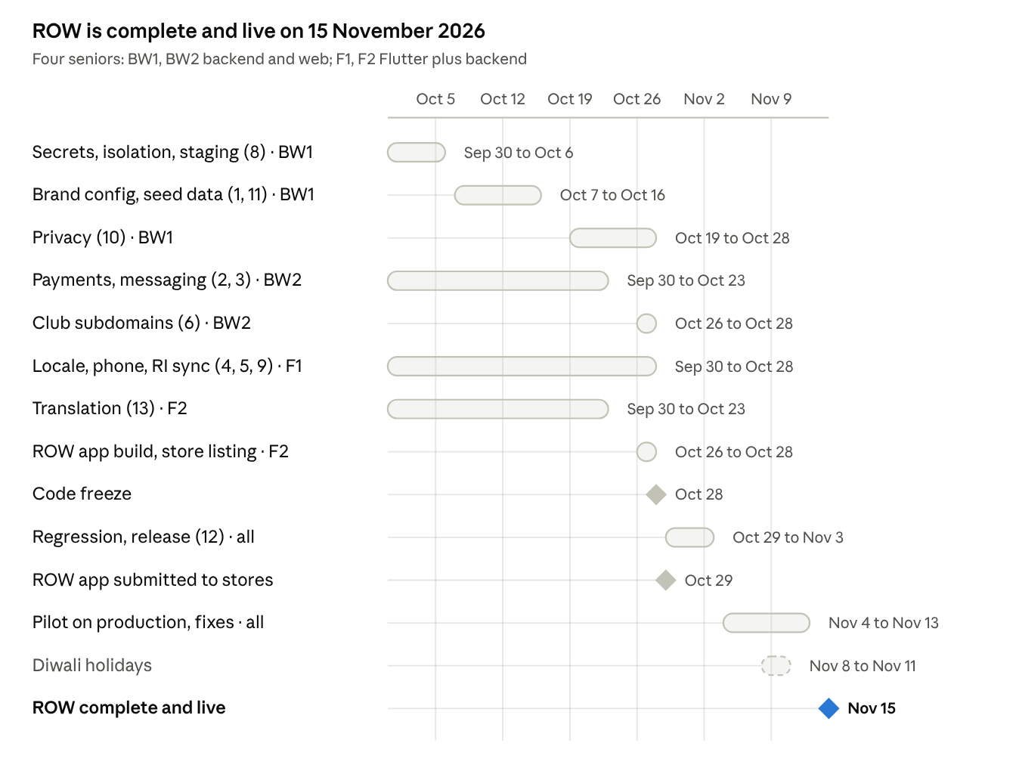
ROW build plan · 30 September to 15 November 2026

Key dates
- Wednesday 28 October: code freeze. After this, only fixes for issues found in regression or the pilot.
- Thursday 29 October: ROW app submitted to the App Store and Google Play.
- Tuesday 3 November: regression complete, same build live on both instances.
- 4 to 13 November: pilot with two or three districts on production. Log every issue with district, screen and steps; fixes follow the normal review rules and ship as patch releases to both instances.
- Sunday 15 November: ROW live.

Launch checklist
ROW is complete only when every item is ticked.
- ☐ Every package above meets its done-when condition.
- ☐ The RIZones smoke suite is green on the release build, and RIZones behaves exactly as before.
- ☐ The ROW app is approved and live on both stores.
- ☐ WhatsApp templates are approved and sending.
- ☐ Rotary International entitlement is active for the ROW zones, and pilot districts are syncing.
- ☐ A restore from backup has been tested for both MySQL instances.
- ☐ The secret scan passes and no key exists in the repository or its history.
- ☐ ROW privacy policy, terms and cookie notice are live.
- ☐ Monitoring alerts reach the team.

Not in this build
Do not start any of these before launch. If a change seems to need one, raise it with the lead dev first.
- Linux containers, and moving ROW off the shared server.
- Custom domains for club websites; ROW clubs get subdomains only.
- Split payments between club and district accounts.
- Self-service member data export and deletion.
- Reporting across RIZones and ROW.

